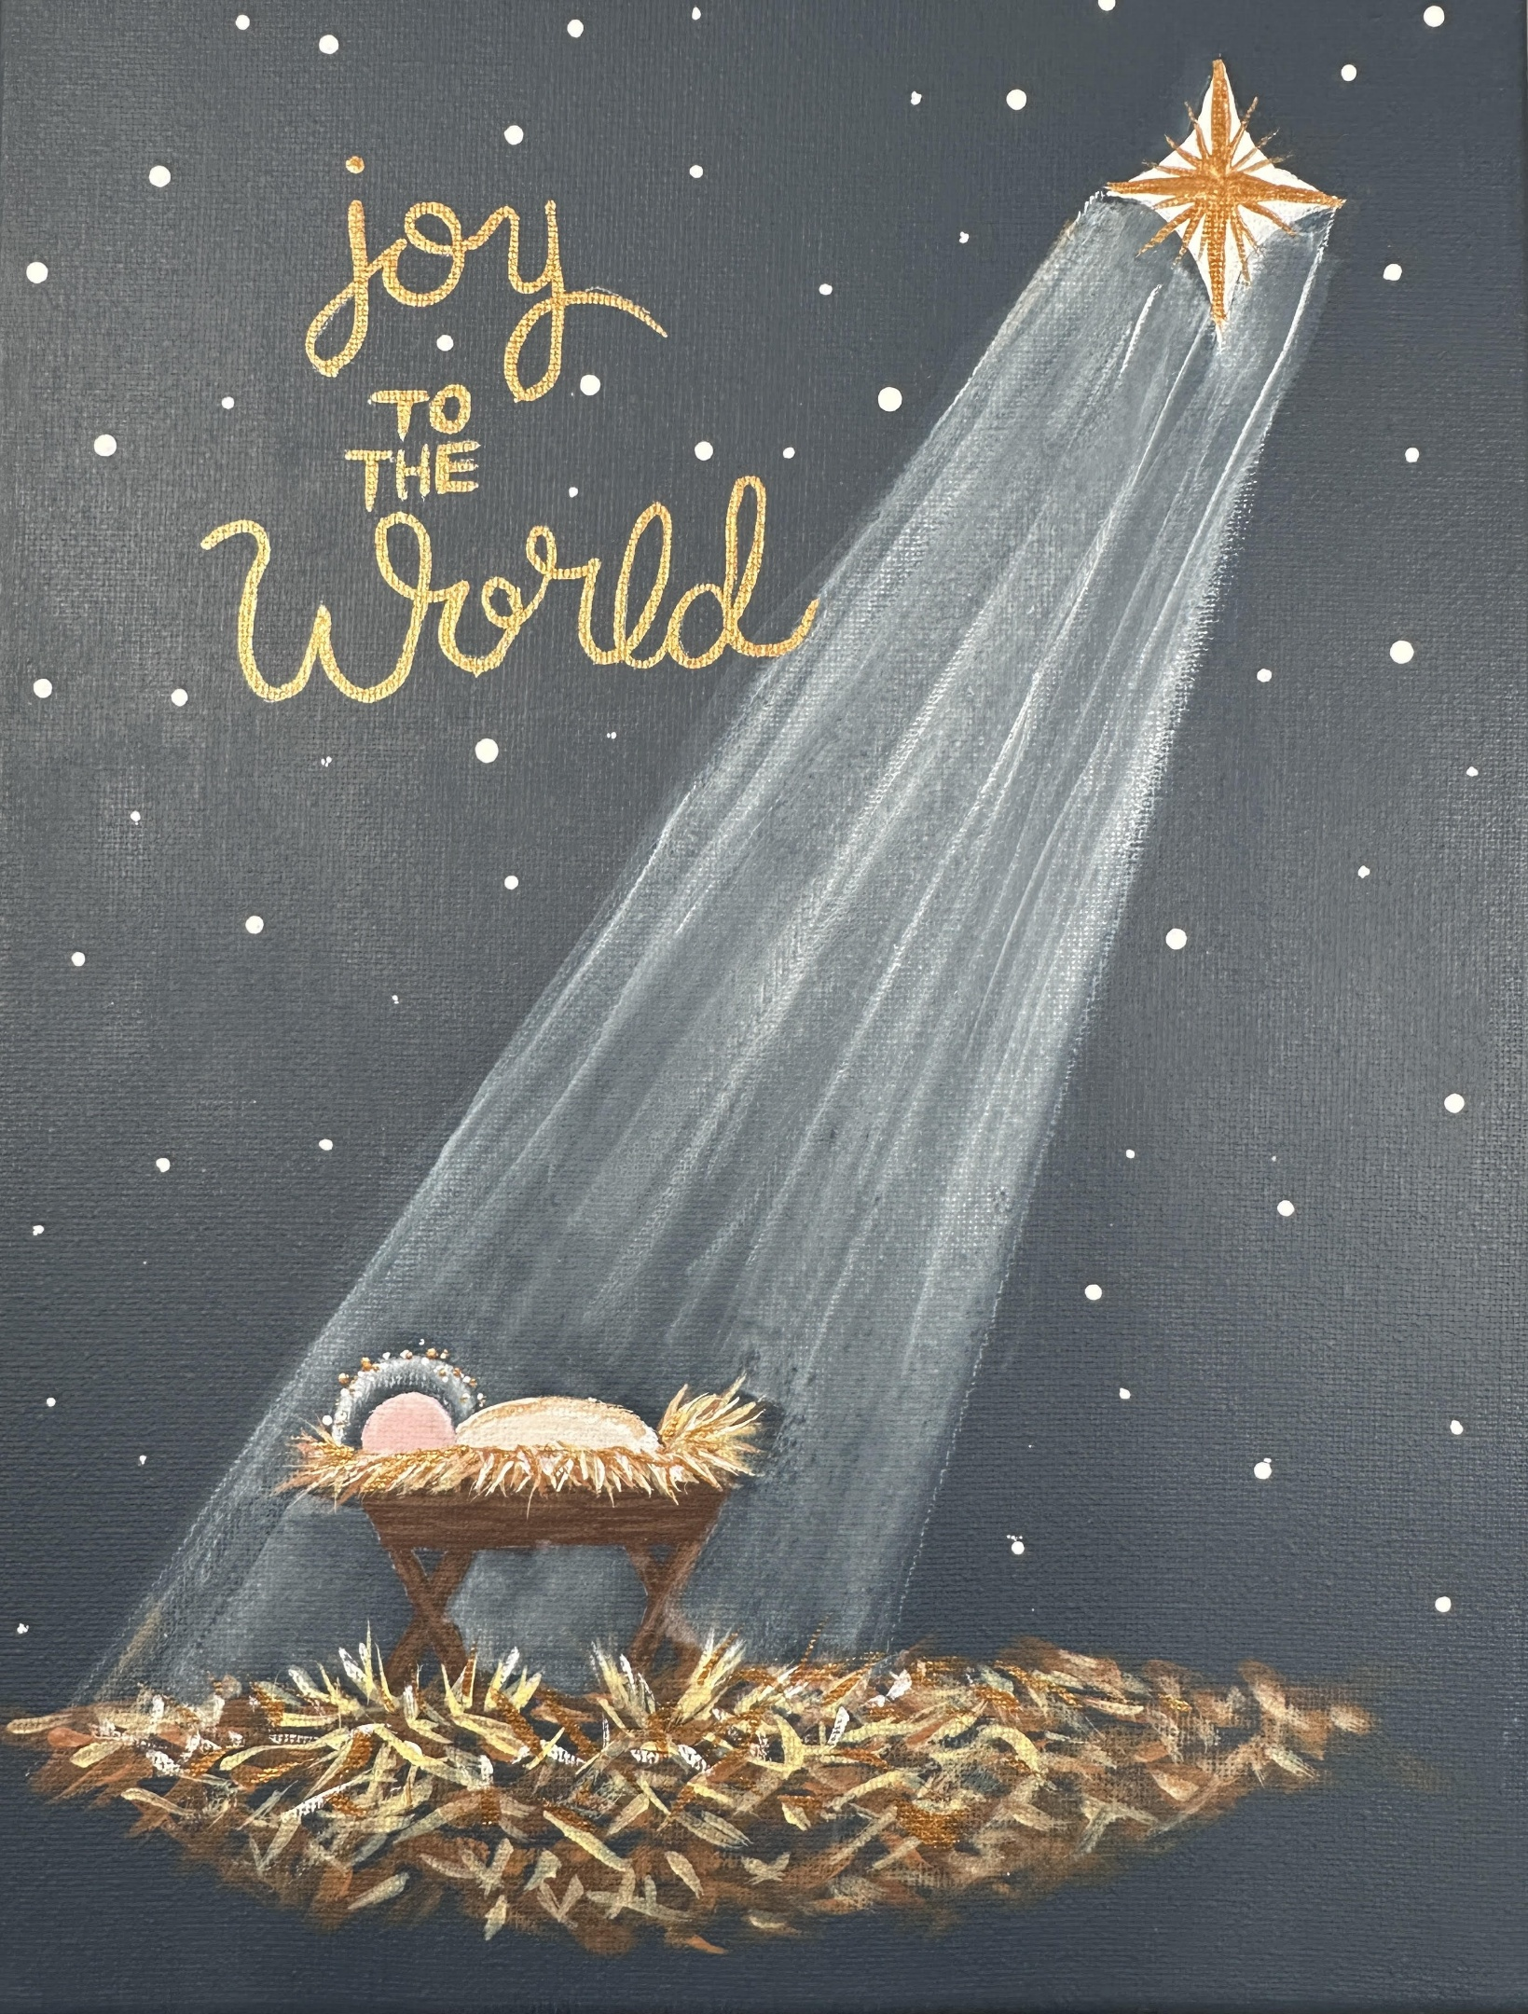
Baby Jesus Paint Party - It will be recorded and available sometime Christmas Eve and you can paint it any time during the holiday week

I have included a photo of a painting that is similar to what we are going to do and a pattern that is almost the same design only flipped.
(I hope that won’t make anyone flip out!!! LOL)
Print off the photo and the pattern.
When you trace the pattern onto tracing paper, you can transfer it onto the canvas from the wrong side of the paper. I use white graphite paper with the white side down on the canvas or a white chalk pencil on the back of the paper – but I’ll show you that in the video tutorial.

Canvas: If you want to include the lettering Joy to the World it would be best to use an 11x14 canvas.
You can use an 8x10 if you like but the painting will be small.

Paint: I like to use Decoart Americana acrylic paints. They cover well so you don’t have to do 5 coats to cover the canvas.
You will need a dark blue for the sky – Deep Midnight Blue
Titanium White
Blush Pink
Raw sienna
Burnt Umber
Black

Brushes: synthetic
¾” flat
½ or 3/8” flat or angled
¼” flat or angled
#3 or #4 round brush
10/0 liner brush or #0 liner
If you get a set of brushes with those in it at Michaels it costs around $15. I get my supplies at www.Michaels.ca or www.stockade.ca or https://www.country-bear-wood.com/
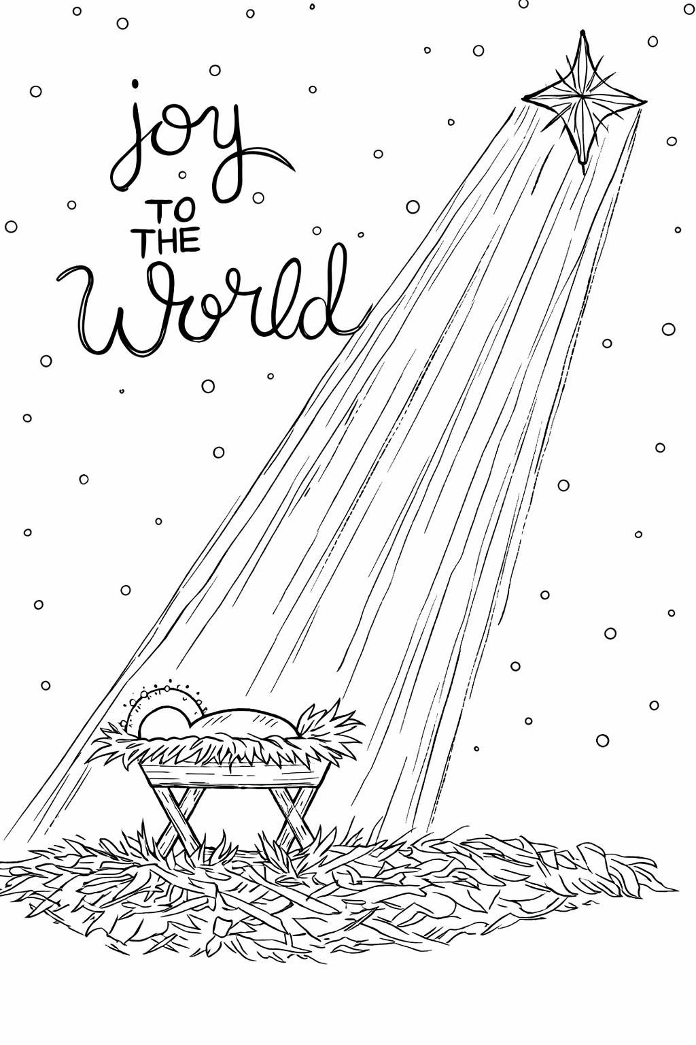www/keepsakesartstudio.com Debbie Eckmier

